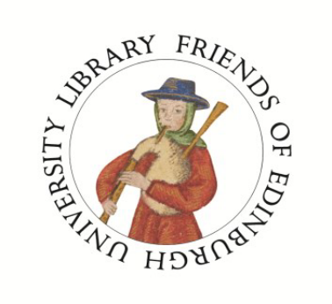

Notice of Extraordinary General Meeting

Wednesday, March 12th, 15:30

5th Floor Seminar Room, Main Library

Notice is hereby given that an Extraordinary General Meeting (EGM) of the members of the Friends of Edinburgh University Library (the Friends) is to be held at 15:30 on Wednesday 12 March 2014 in the 5th Floor Seminar Room of the Main Library, George Square. This meeting will have a single agenda item: to consider a new Constitution of the Friends.

To consider, and, if thought fit, to pass the following resolution :

“That the draft revised Constitution submitted to the meeting is approved and adopted as the Constitution of the Friends of Edinburgh University Library in substitution for, and to the exclusion of, the existing Constitution of the Friends”.

The original Constitution of the Friends was first written for the establishment of the Friends, in 1962. The Constitution now requires revising in order to bring it up to date, in line with current legal requirements. The present changes to the Constitution have been discussed in the Committee of the Friends, and are now proposed by the Committee. A copy of the proposed draft Constitution is included with this notice.
All members of the Friends may attend the EGM and vote on the resolution. Members may also comment in writing to the Administrator of the Friends, at a.roberts@ed.ac.uk or to Alason Roberts, Main Library; George Square; Edinburgh; EH8 9LJ
The meeting will be followed by a talk entitled “Over 400 years of experience” on the University Archives, by Grant Buttars, Deputy University Archivist. See the enclosed sheet for details.
Further dates for your diary include:
March 27th exhibition private viewing (see enclosed invitation )
June 19th summer visit, to the refurbished Scottish Collections at Edinburgh Public Libraries
October 7th event (details to follow)
November 25th AGM + event (details to follow)

