

Annual General Meeting

to be held at CRC, 6th Floor, Main Library

Thursday 20th November 2025 at 15:00

Followed (at 15:30) by:

Re:Connect, The Library and Collections Annual Report
Celebrating a year of service and collecting!

Jeremy Upton, Director of Library and University Collections, and Daryl Green, Co-Director of the Centre for Research Collections, will introduce the Library and Collections Annual Report, Re:Connect, and some of those Library and Collections staff who have worked on it.
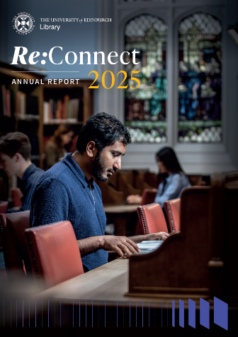
Each year, Library services change to meet new demands and developments, just as the University collections grow through donations, bequests, transfers and purchases. Library and Collections staff - expert information professionals, curators, librarians and archivists - work with a whole range of communities to ensure that the services and unique collections are grown responsibly and in a way that reflects current academic interests and sector best practice. Informing, updating and sharing Library and Collections achievements is the object of this report.

Attendees are encouraged to bring guests. Refreshments will be served.

Please let us know by Friday 7th November if you are able to attend by emailing to Alason Roberts, Administrator to the Friends (a.roberts@ed.ac.uk) or write to Alason Roberts; Friends of EUL; Main Library; University of Edinburgh; George Square; Edinburgh EH8 9LJ

